**IN5520/IN9520 Mandatory term project 2018**

**Segmentation of textured regions in an image**

**Hao, Zhao**

**Department of Geosciences,**

**University of Oslo**

**Problem Description**

In this project of segmentation of textured regions in an image. We are going to analyzing the texture within the images by using the Gray Level Co-occurrence Matrix (GLCM) method and using the selected GLCM derived features (GLCM homogeneity, GLCM intertie and GLCM cluster shade) and proper global thresholding to separate the variant textures and texture’s boundary within the image, which is the segmentation in imaging analysis.

The Gray Level Co-occurrence Matrix (GLCM) is a statistical tool to measure the texture of an image by counting the co-occurring gray level at a given pixel offset(dx,dy). In image analysis, GLCM is the estimation of the second order join probability, which measure the gray level repetitions from gray level ‘i’ to gray level ‘j’ at given pixel distance and direction. The co-occurrence matrix is defined as equation (1)

$C\left(i,j\right)= \sum_{x=1}^{n}{\sum_{y=1}^{m}{\left\{\begin{aligned}1, if(I\left(x,y\right)=i and I\left(x+dx,y+dy\right)=j \\ 0, otherwise\end{aligned}\right.}}$ (1)

Where index I and j represent the pixel values, the x, y are the spatial coordinates within the image, and dx, dy are the displacement of analyzing point pairs which are moving in the defined direction and offset. The GLCM matrix is always normalized to represent the probability of gray level variation, and symmetric transformed before it is used to GLCM features calculation. By select the specific direction and offset, the GLCM matrix can be used to classify the different image textures (segmentation).

By using GLCM for image segmentation, we firstly employ a sliding window to analyze the GLCM on a local image defined by the central pixel and neighboring pixels, then we multiply the GLCM matrix with the defined weight functions and sum over all the weighted elements to a scalar which is saved to the central pixel location of the output GLCM feature map. There are many GLCM features used in the image analysis, the most popular features among the image segmentation are GLCM homogeneity, GLCM inertia and GLCM cluster shade. The GLCM homogeneity feature highlights the homogeneity of the texture with large values. On the contrary, GLCM inertia is more favor of inhomogeneity in the image, thus it gives high values to inhomogeneous areas. The GLCM cluster shade is also a tool to measure the asymmetry of the image which use high value to represent the asymmetric of an image. In the following, we will use a detail example to explain the usage of GLCM and GLCM features for the image segmentation.

**Numerical Result**

1. **Analyzing the textures.**

In this project, we are using two mosaic pictures which contain different texture elements for the segmentation of textured region test.

In the first mosaic picture (cf. Fig. 1 left), 4 major textures are combined in this figure. The texture on the top left of figure 1 shows strong inhomogeneous and variation with respect to the gray level intensity. In the top right, the texture varies less, and the weak vertical and horizontal strips are embedded. For the texture in the bottom left, most of the elements of the texture present in the dominant direction around -30 degree or +150 degree. The last texture in the bottom right is similar to the texture in the top left, but with more inhomogeneity.

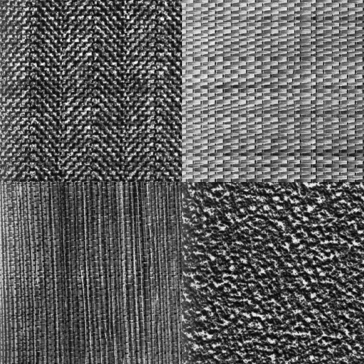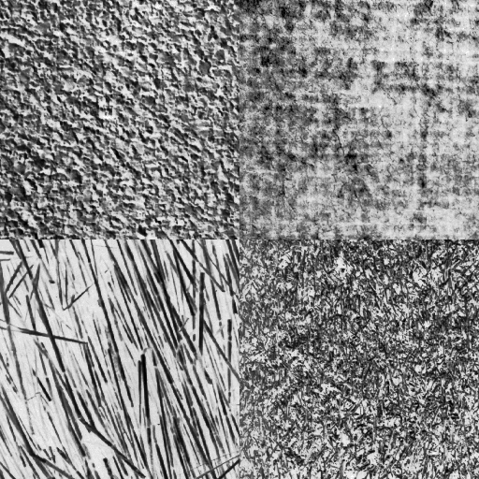In the second mosaic picture (cf. Fig. 1 right), there are also 4 different textures. On the top left, the texture is composed of the repeated crossed strips with dominant direction: +45 degree and -45 degrees. The top right texture is the repetition of small tilted bricks. In the bottom left, the texture mainly includes the near vertical strips. In the bottom right, the texture is a rough surface without the apparent direction for the texture elements.

Figure 1. Mosaic pictures-1 (left) and Mosaic pictures-2(right)

1. **Visualizing GLCM matrices**

In this part, in order to analyze the texture in detail, the above two figures are separated into 8 individual figures which represent 8 different textures. Prior to the derivation of Gray Level Co-occurrence Matrix (GLCM), the initial texture images are preprocessed with histogram equalization to enhance the contrast of the original image, and with the downscale of gray level intensity from original 256 to 16 to speed up the GLCM calculation. The following figure2 to figure9 present the original texture image, the histogram equalized texture image and gray level downscaled texture image. The corresponding histograms are also displayed.

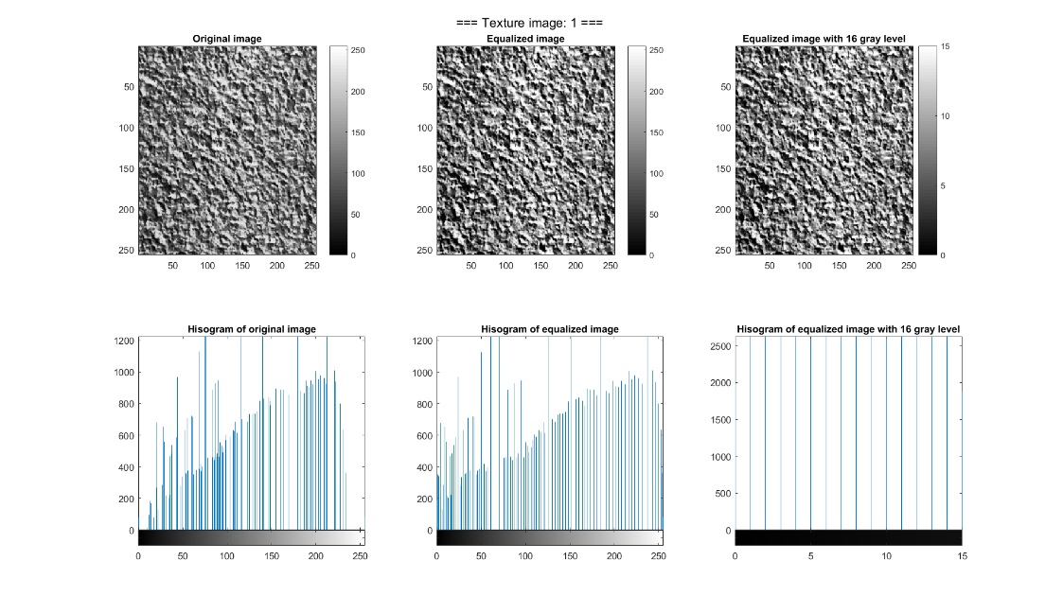

Figure 2. Original, histogram equalized, and gray level downscaled texture image-1

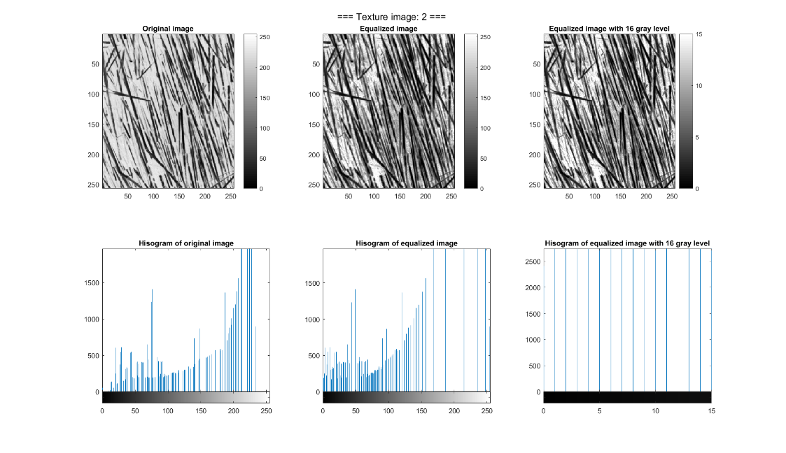

Figure 3. Original, histogram equalized, and gray level downscaled texture image-2

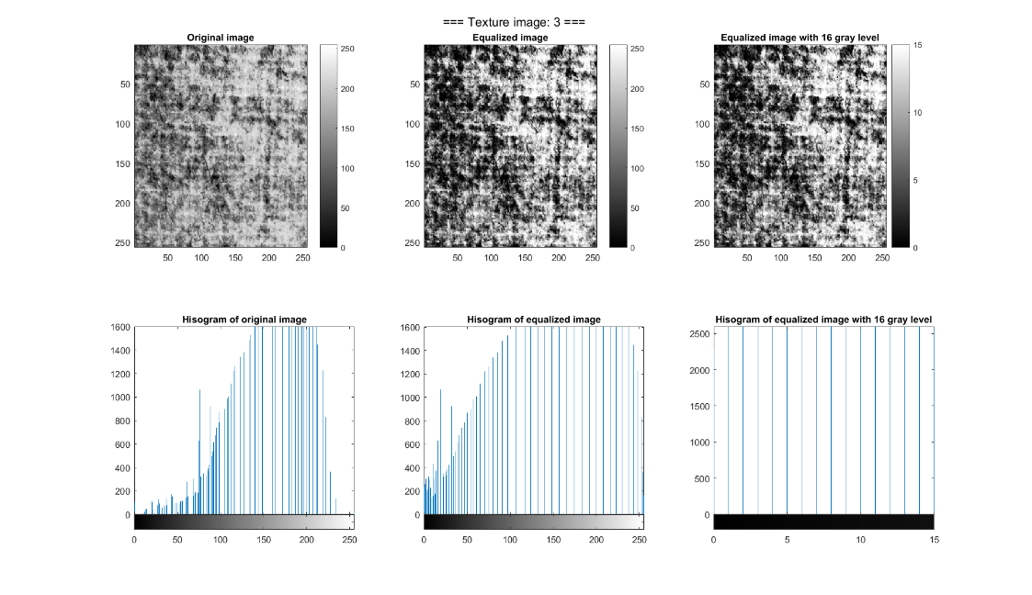

Figure4. Original, histogram equalized, and gray level downscaled texture image-3

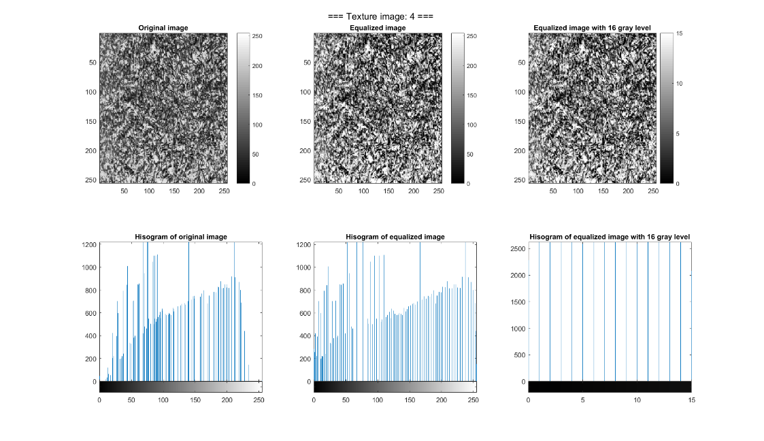

Figure 5. Original, histogram equalized, and gray level downscaled texture image-4

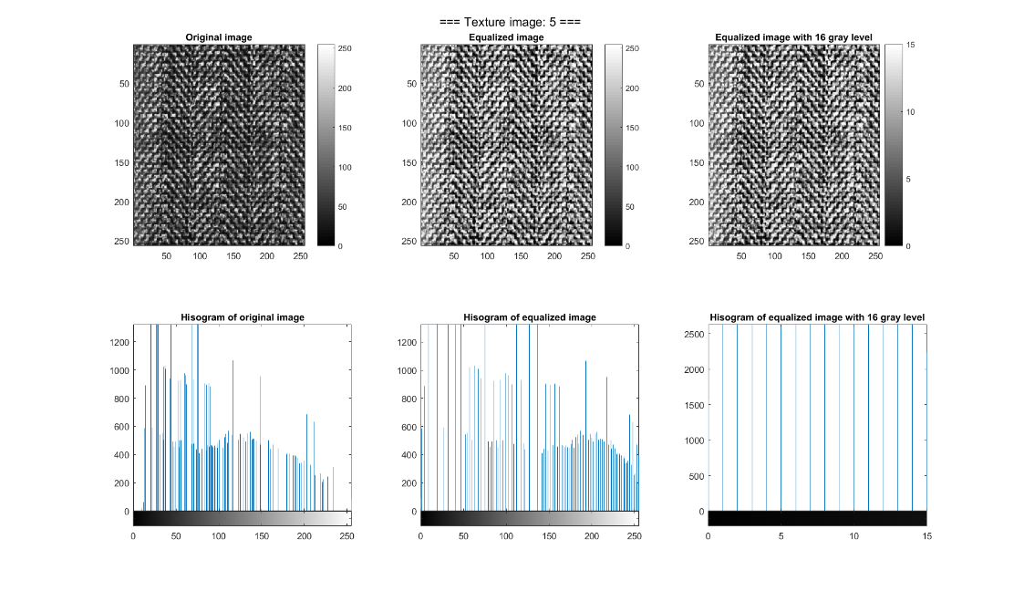

Figure 6. Original, histogram equalized, and gray level downscaled texture image-5

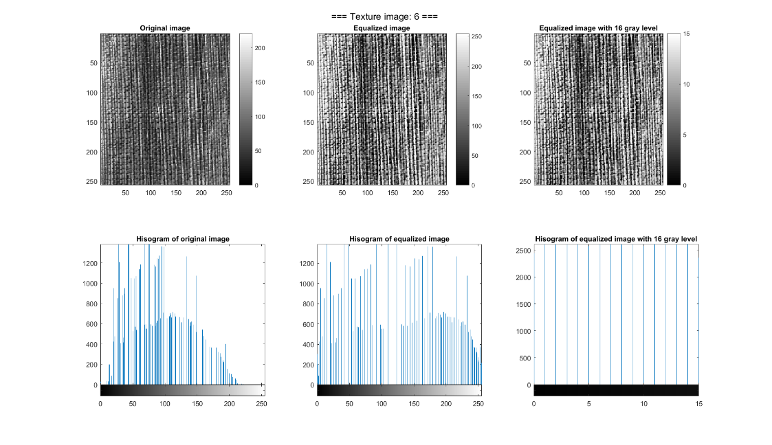

Figure 7. Original, histogram equalized, and gray level downscaled texture image-6

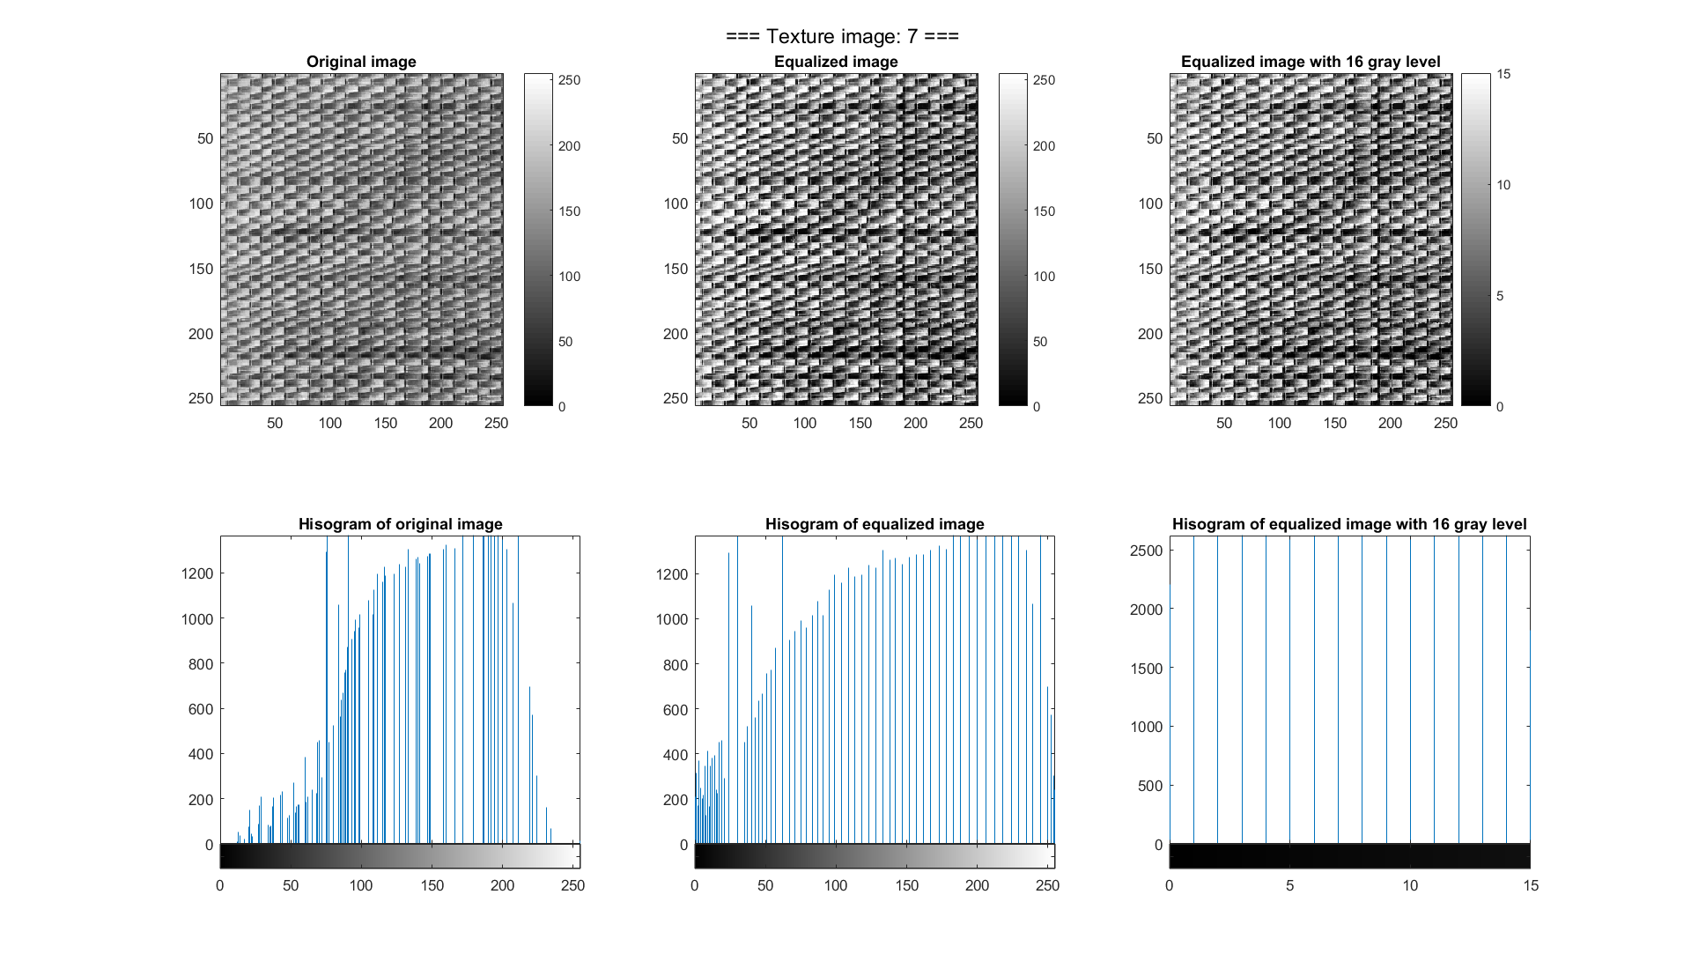

Figure8. Original, histogram equalized, and gray level downscaled texture image-7

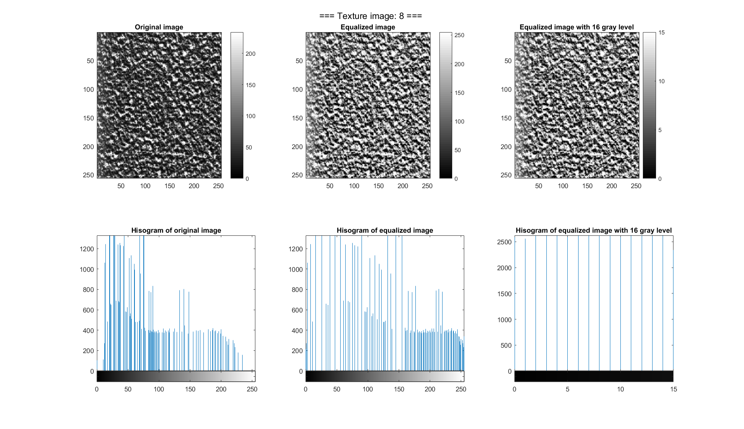

Figure 9. Original, histogram equalized, and gray level downscaled texture image-8

After the histogram equalization and gray level reduction, the GLCM matrices are calculated based on the selected calculation direction and distance (d,θ). From the observation we had on all the textures, we have chosen the isotropic GLCM for the texture type-1, type-4 and type-8 considering these textures don’t include patterns with clear directions. The isotropic GLCM is derived by averaging the normalized and symmetric GLCM from the four angels {0 o,45 o,90 o,135 o}.

For texture 2 and 6, which has the pattern with the near vertical direction, we select the angels {90 o} for the GLCM calculation. For those textures with both horizontal and vertical patterns, we used angles {0 o, 90o} for the GLCM calculation. The texture 5 has the repeated pattern from both 45 o,135o directions, thus we use these directions in GLCM calculation. The following figures 10-17 present the texture and corresponding GLCM matrix based on the selected analyzing angle. All these derived GLCM matrix used no more than 1 gray level step for calculation.

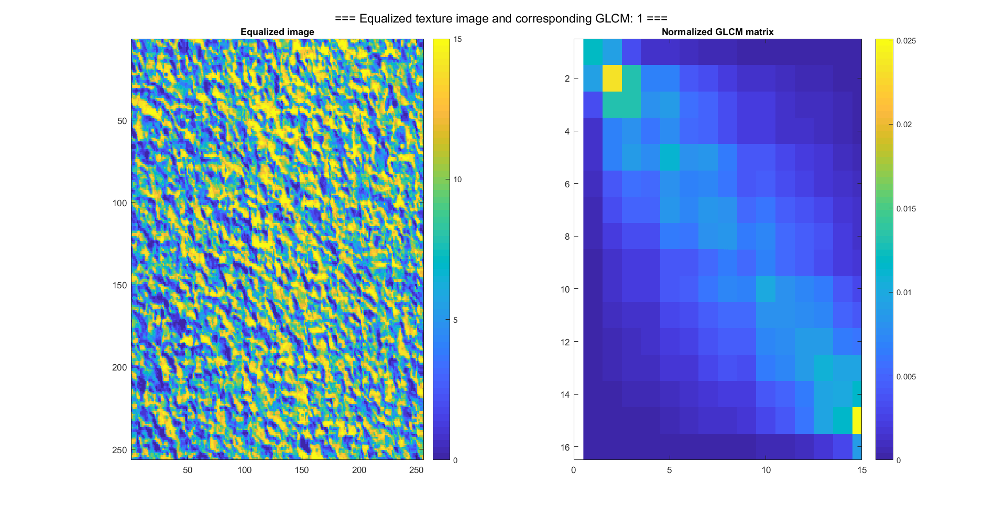

Figure 10. Texture image-1 and GLCM

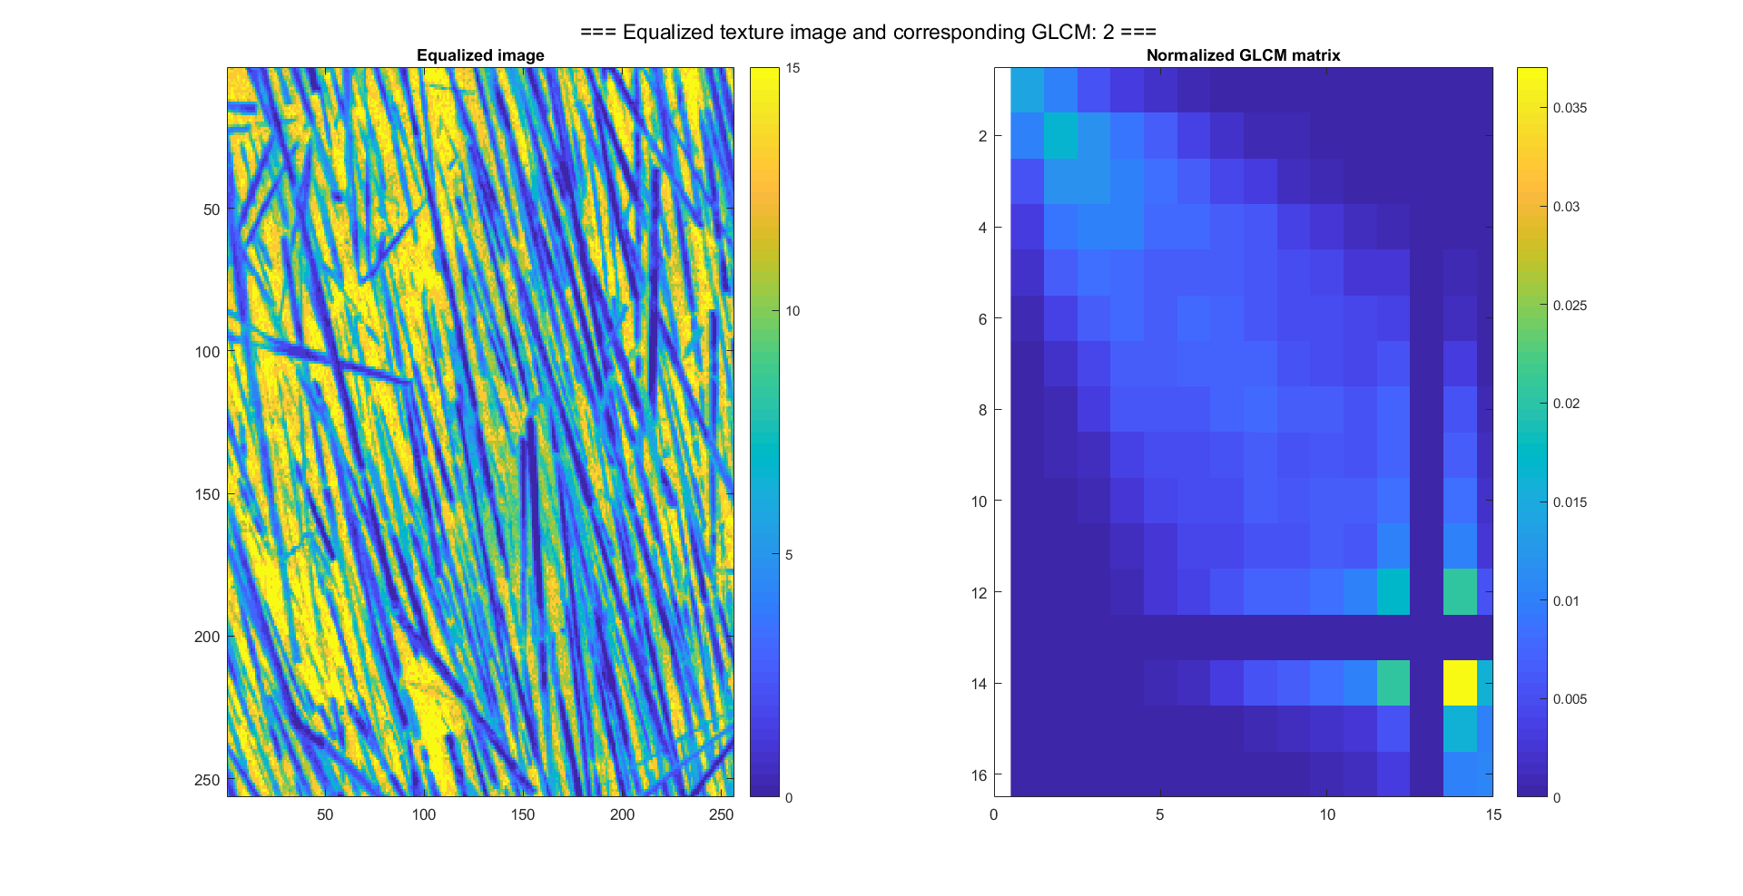

Figure 11. Texture image-2 and GLCM

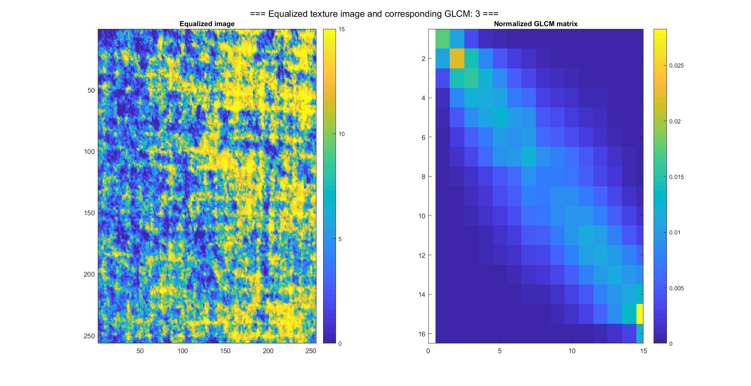

Figure 12. Texture image-3 and GLCM

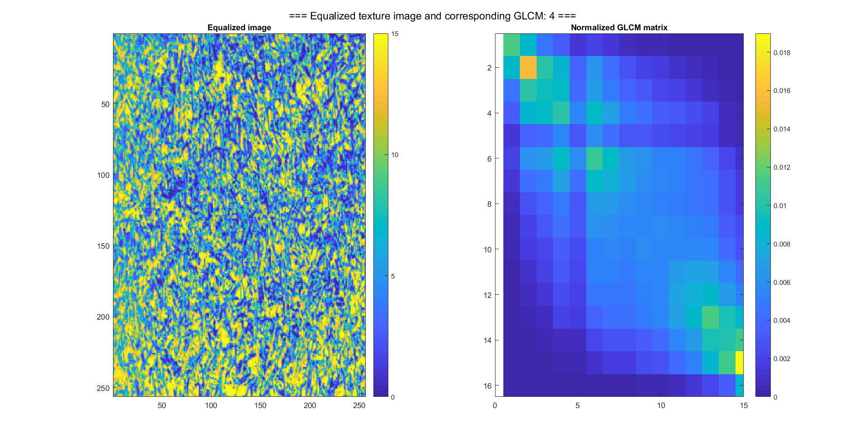

Figure 13. Texture image-4 and GLCM

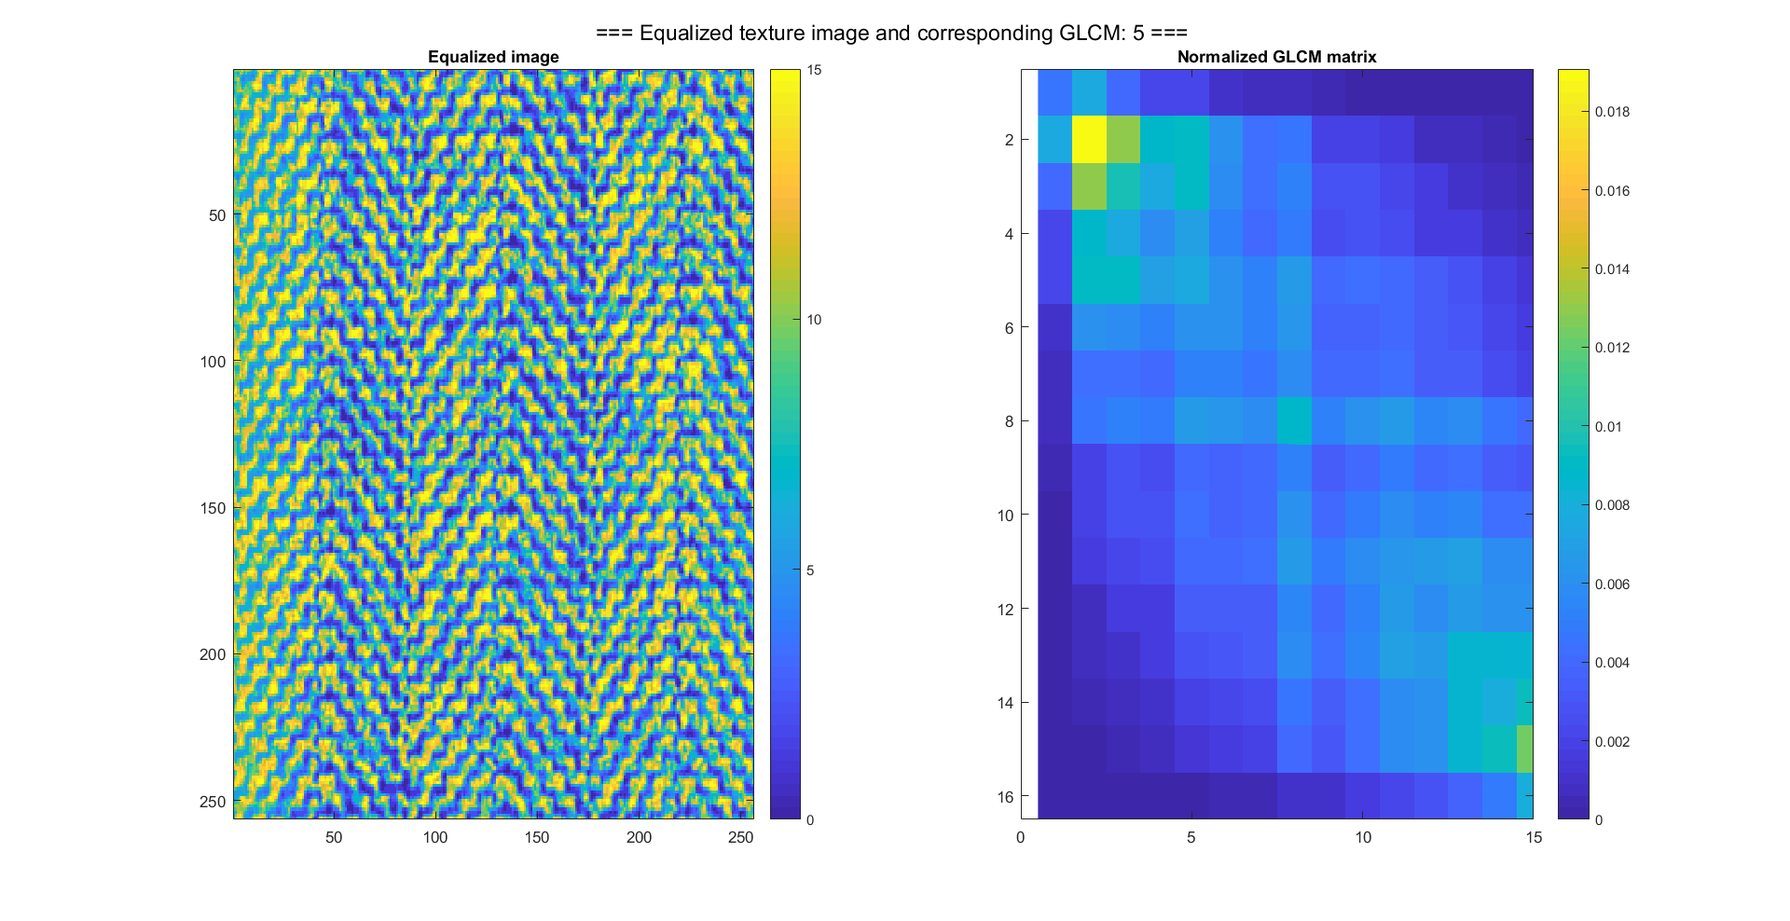

Figure 14. Texture image-5 and GLCM

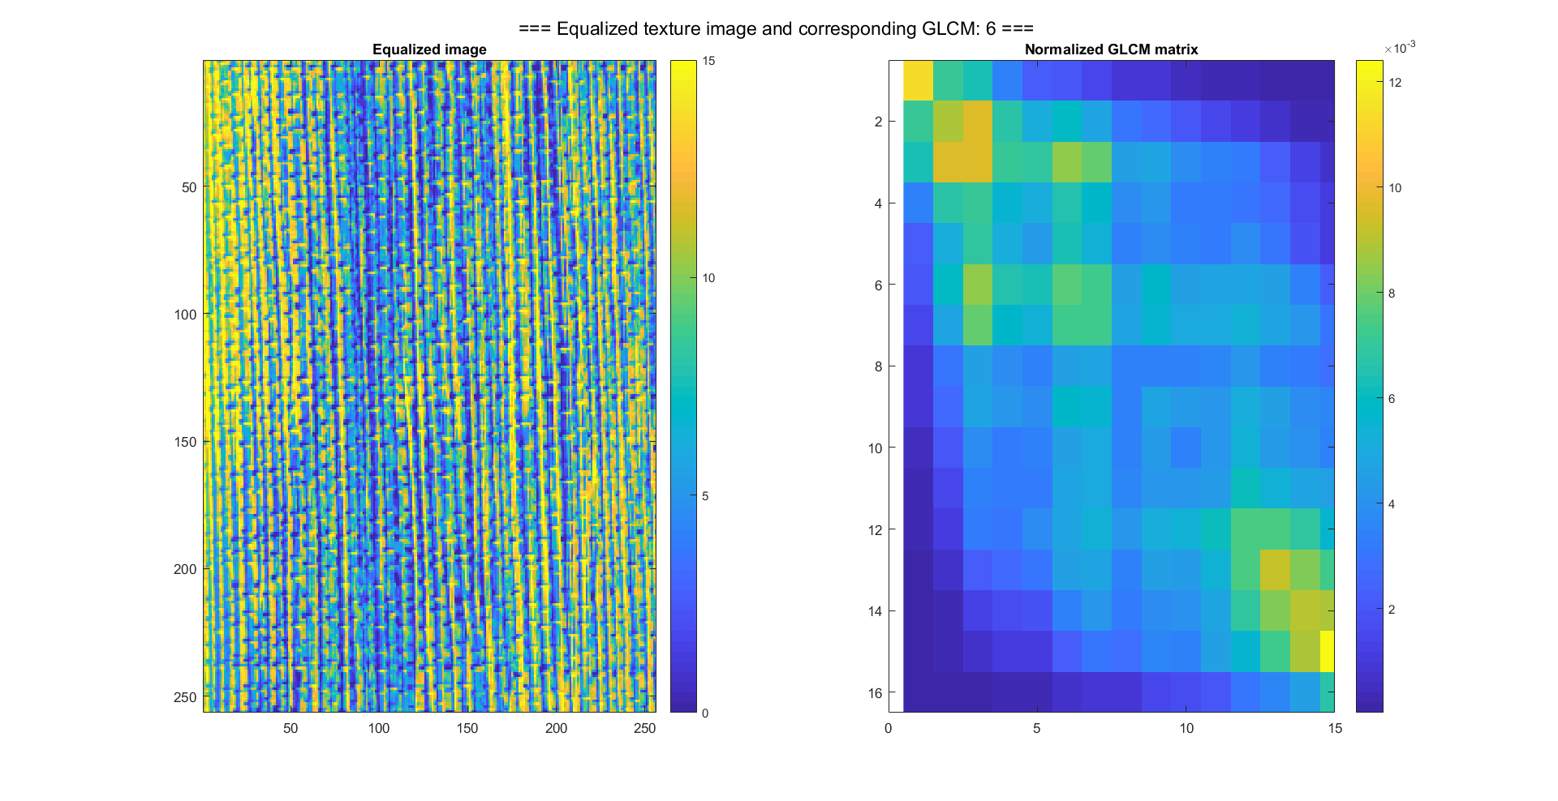

Figure 15. Texture image-6 and GLCM

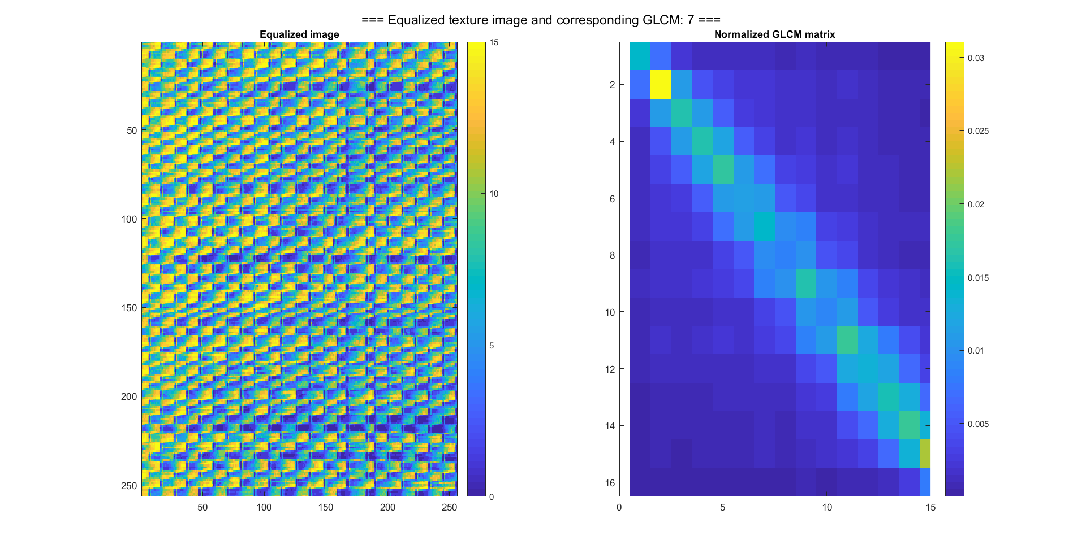

Figure16. Texture image-7 and GLCM

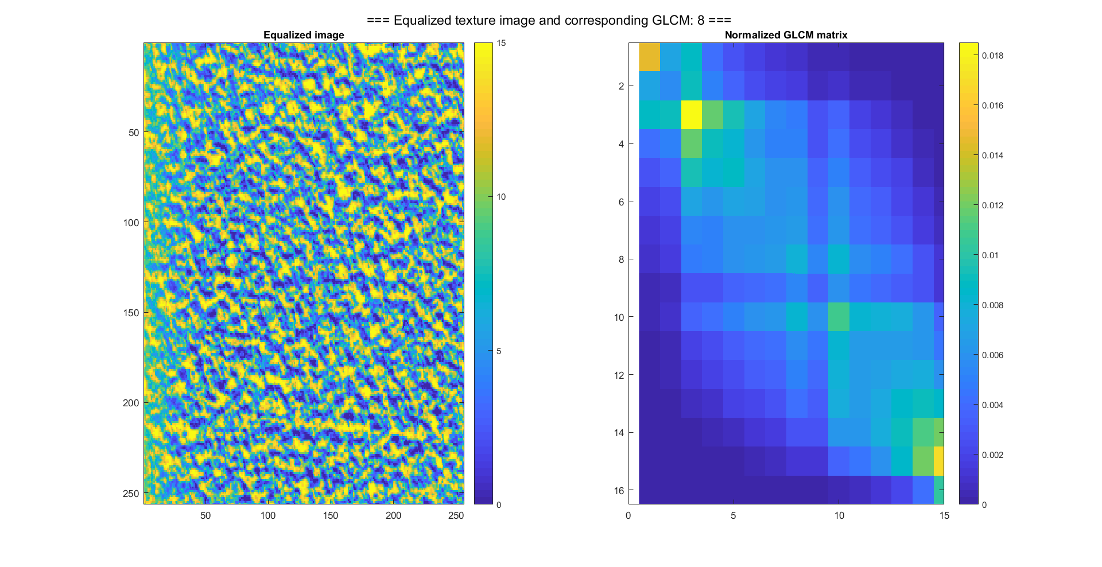

Figure 17. Texture image-8 and GLCM

1. **Computing GLCM feature images in local windows**

In order to discriminate the textures within the two mosaic images, we have to make use of the GLCM features. The GLCM feature image is derived with: (1) calculation of the GLCM for local image within a sliding window (2)multiply the GLCM with the feature weights, (3) assign the summation value of step(2) into the central grid location of the output matrix , and (4) slide the window and repeat the process (1)-(3) to all the samples.

In the sliding window GLCM feature calculation, the window size is a critical parameter for the feature derivation. Too small window will lead to inaccurate features, and too large small window will mix the multiple textures thus blur the edges in the following image segmentation. In this test, we tried different window size, and select window size(31 x 31) for the local GLCM calculation.

The GLCM features are dependent on the GLCM matrix calculated within the sliding windows. Thus, the angle direction chosen for GLCM analysis is important to the derived GLCM features. In this exercise, based on the texture analysis from part-A, and the selected GLCM calculating angles from Part-B, the GLCM features (GLCM homogeneity: IDM, GLCM innertia: IMR, and GLCM cluster shade: SHD) are calculated. The following figures: 18-25 present the mosaic image and corresponding GLCM features derived from selected analyzing angle of GLCM.

With respect to the GLCM features, the homogeneity feature (IDM) highlight the homogeneity of an image, thus it will have high value for the homogeneous areas, and low value for the inhomogeneous areas. The inertia feature (IMR) is opposite to homogeneity. It always gives high value for areas with large level contrast.

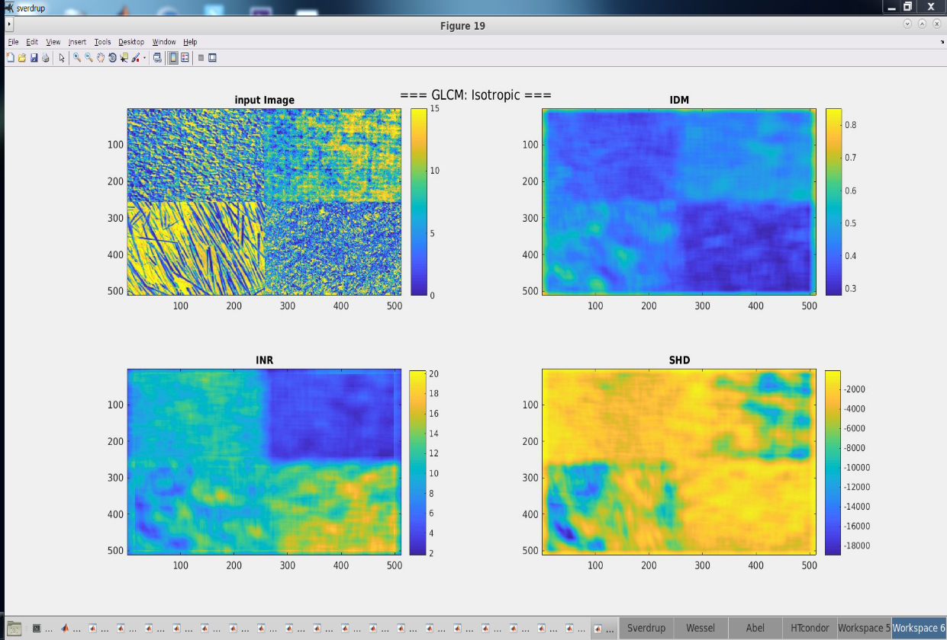

Figure 18. Mosaic-1 and GLCM features calculated by Isotropic GLCM with window 31x31

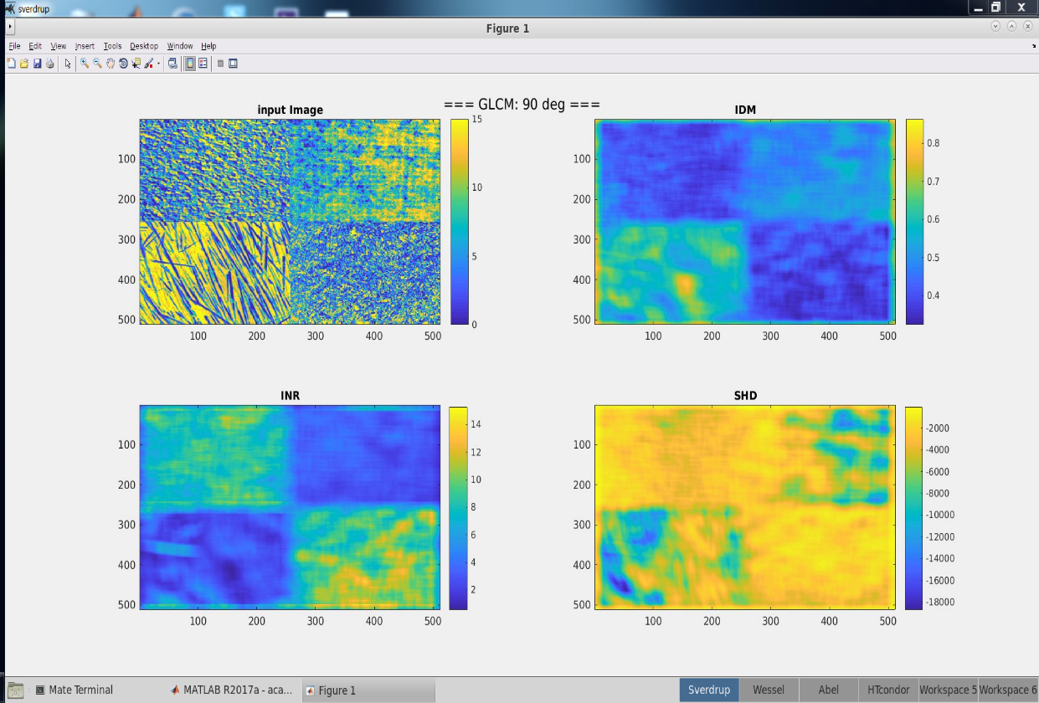

Figure 19. Mosaic-1 and GLCM features calculated by GLCM(90deg) with window 31x31

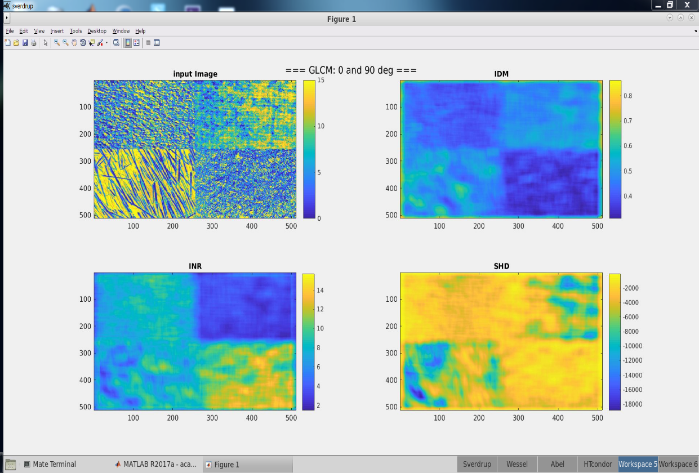

Figure 20. Mosaic-1 and GLCM features calculated by GLCM (0 deg& 90deg)

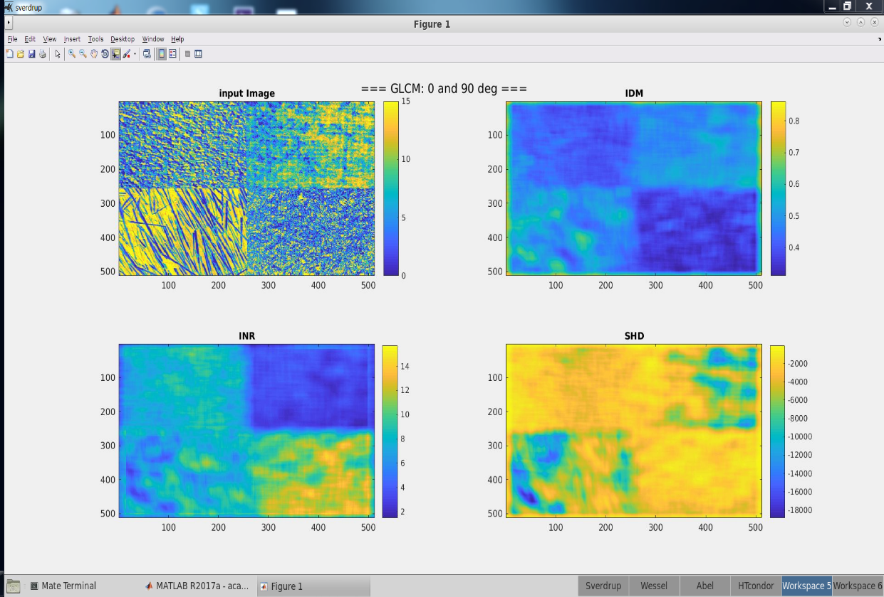

Figure 21. Mosaic-1 and GLCM features calculated by GLCM (0 deg& 90deg)

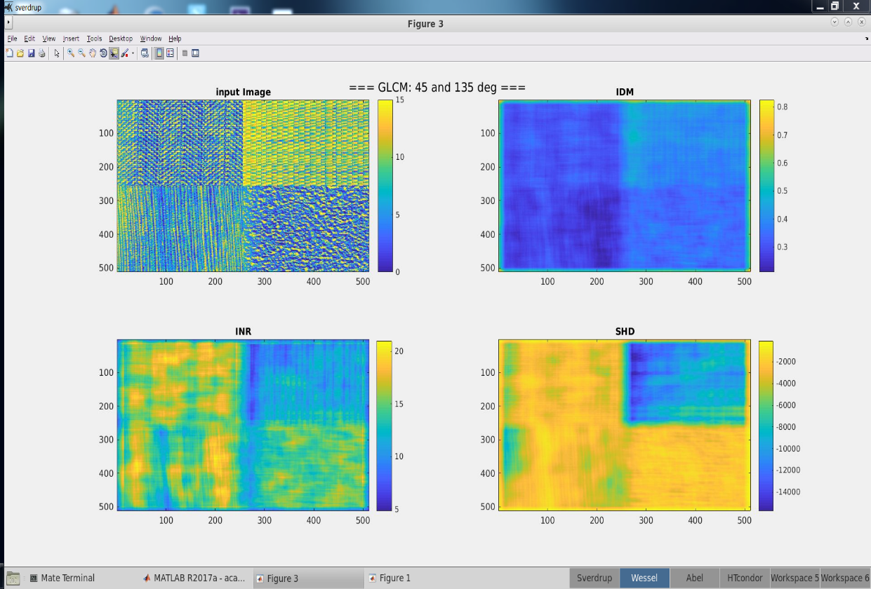

Figure 22. Mosaic-2 and GLCM features calculated by GLCM(45 deg& 135deg)

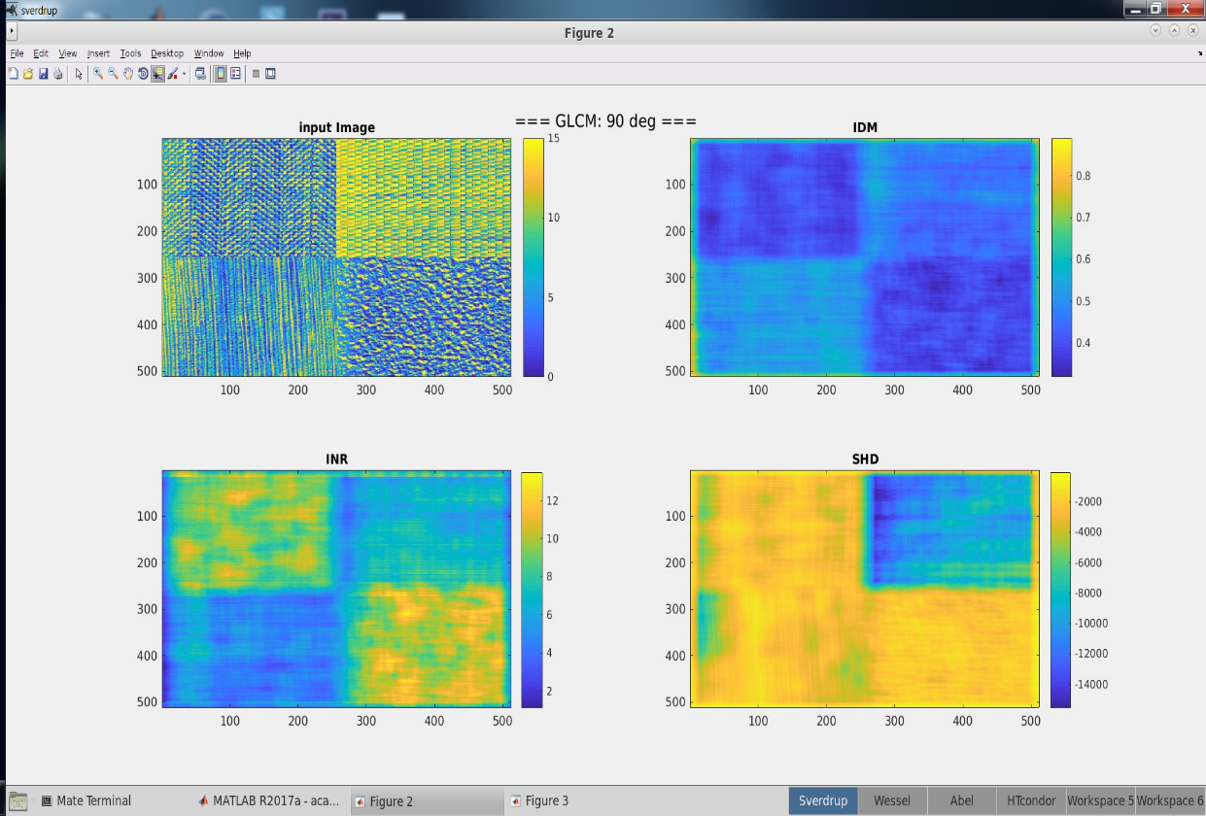

Figure 23. Mosaic-2 and GLCM features calculated by GLCM(90deg)

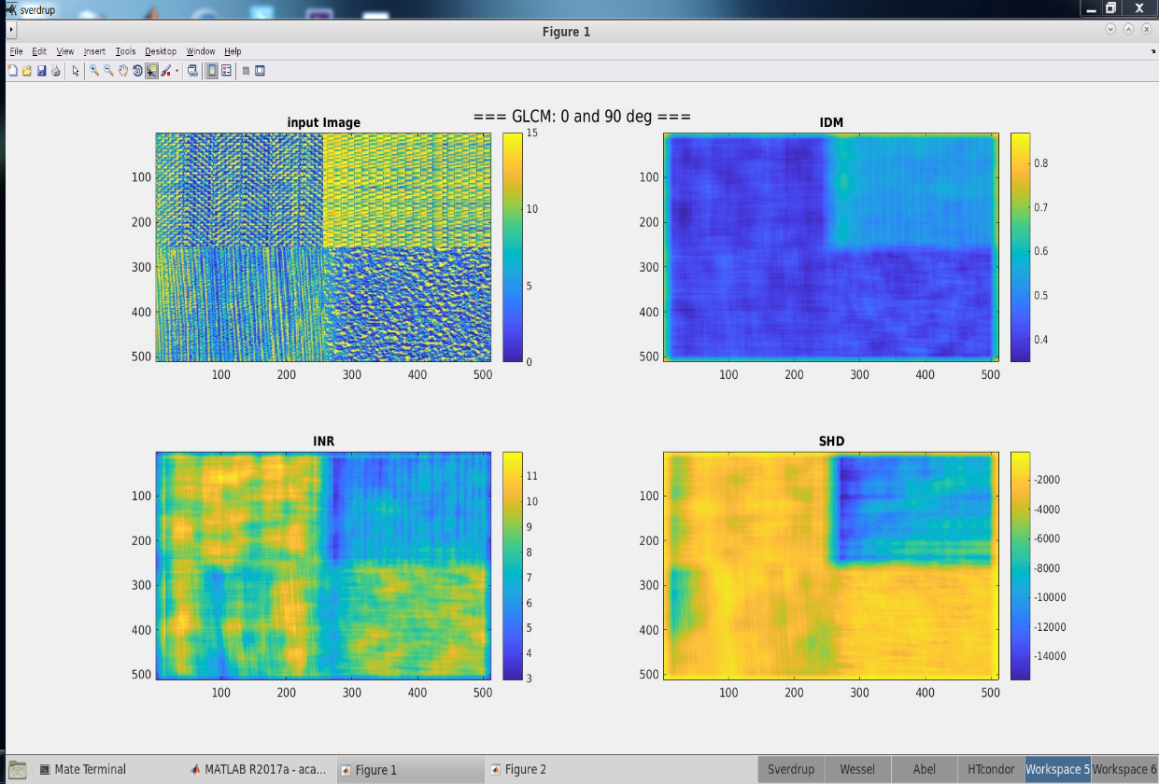

Figure 24. Mosaic-2 and GLCM features calculated by GLCM(0 deg& 90deg)

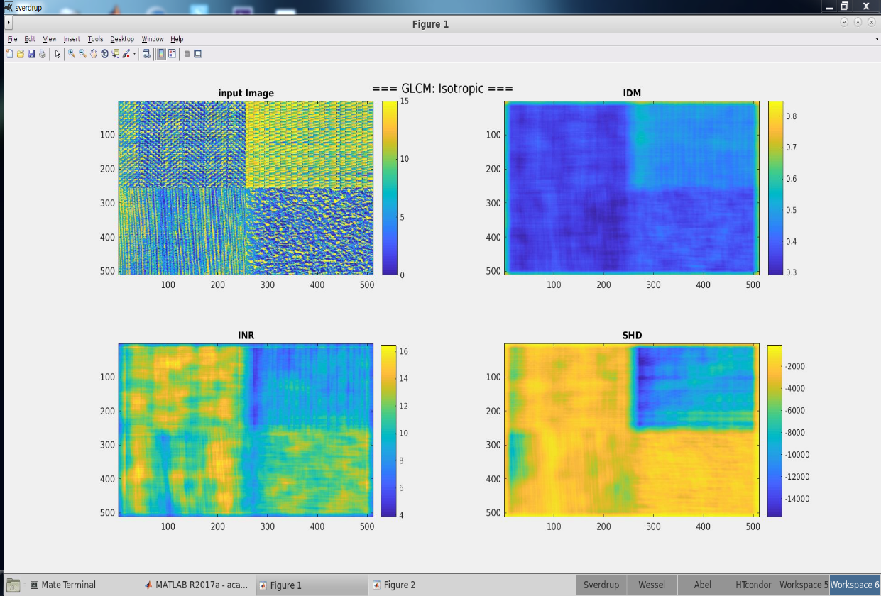

Figure 25. Mosaic-2 and GLCM features calculated by Isotropic GLCM

1. **Segment the GLCM feature images and describe how they separate the textures**

Based on the derived GLCM features from Part-C, we derived the below threshold for the discrimination of the specific textures within the two mosaic images.

* + Tetxure-1: 10 < abs(GLCM_feature_INR) < 12
  + Texture-2: abs(GLCM_feature_IDM) > 0.55
  + Texture-3: abs(GLCM_feature_INR) < 5
  + Texture-4: abs(GLCM_feature_IDM) < 0.4
  + Texture-5: abs(GLCM_feature_INR) > 15
  + Texture-6: abs(GLCM_feature_INR) < 5
  + Texture-7: abs(GLCM_feature_SHD) > 6000
  + Texture-8: 10 < abs(GLCM_feature_INR) < 12

The following figure: 26-33 demonstrate the original mosaic figures, and the threshold applied figures. By comparing the specific texture location and the segmentation result, we can see that for those textures (2,3,4,5,6,7) including patterns with specific directions are easier to be discriminated by selecting the proper GLCM calculation angles. While for those textures (1,8) without apparent dip features are hardly differentiated based on GLCM features.

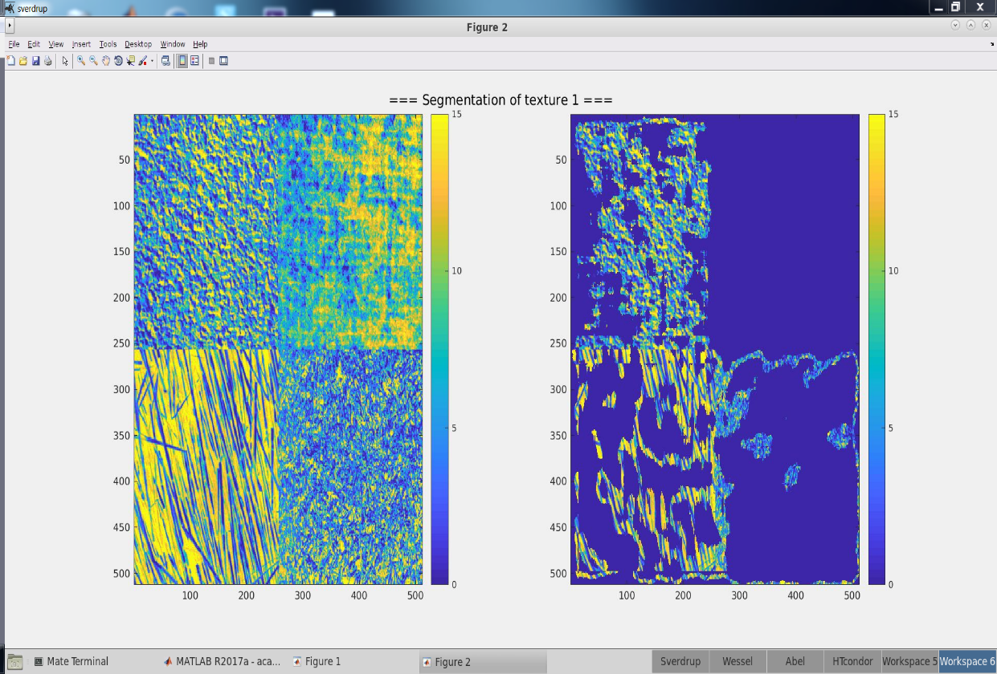

Figure 26. Mosaic-1 and threshold applied image to identify texture-1

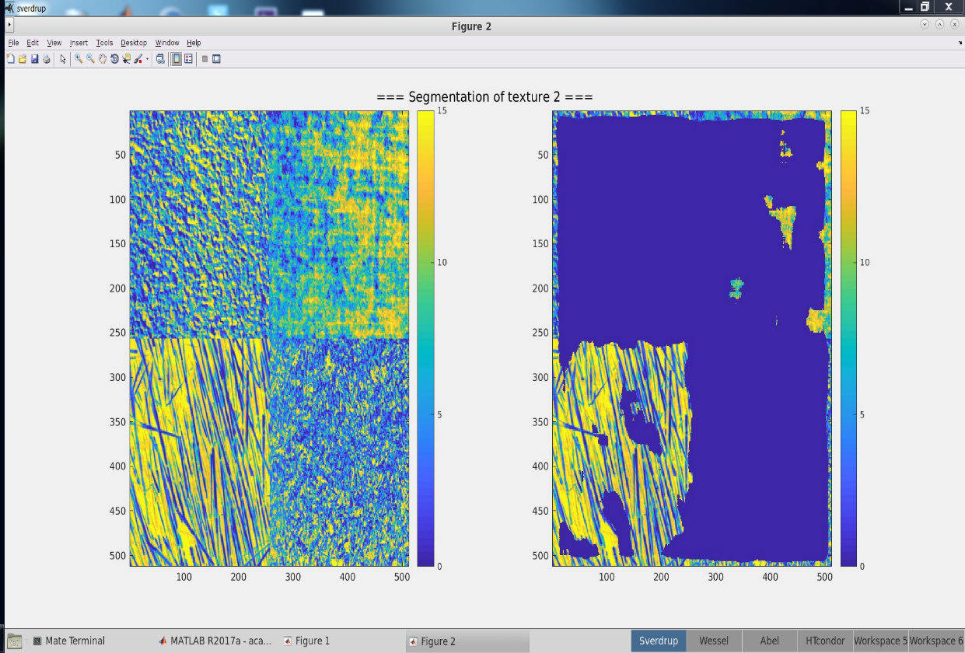

Figure 27. Mosaic-1 and threshold applied image to identify texture-2

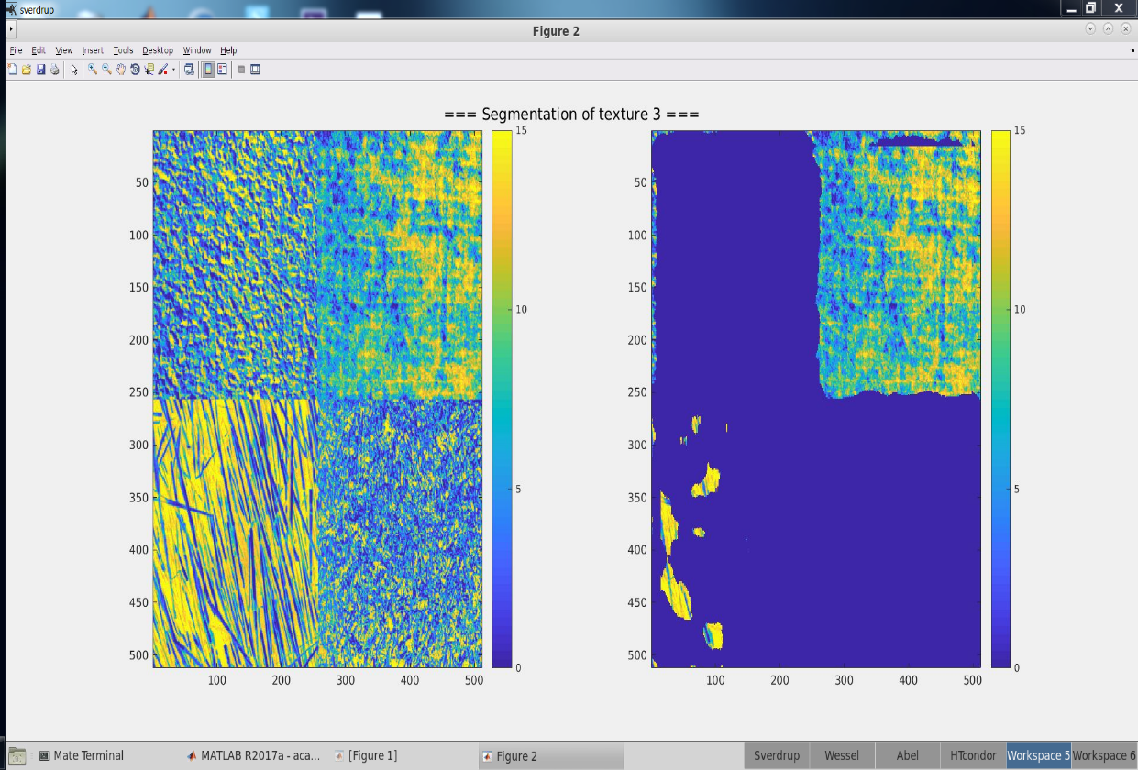

Figure 28. Mosaic-1 and threshold applied image to identify texture-3

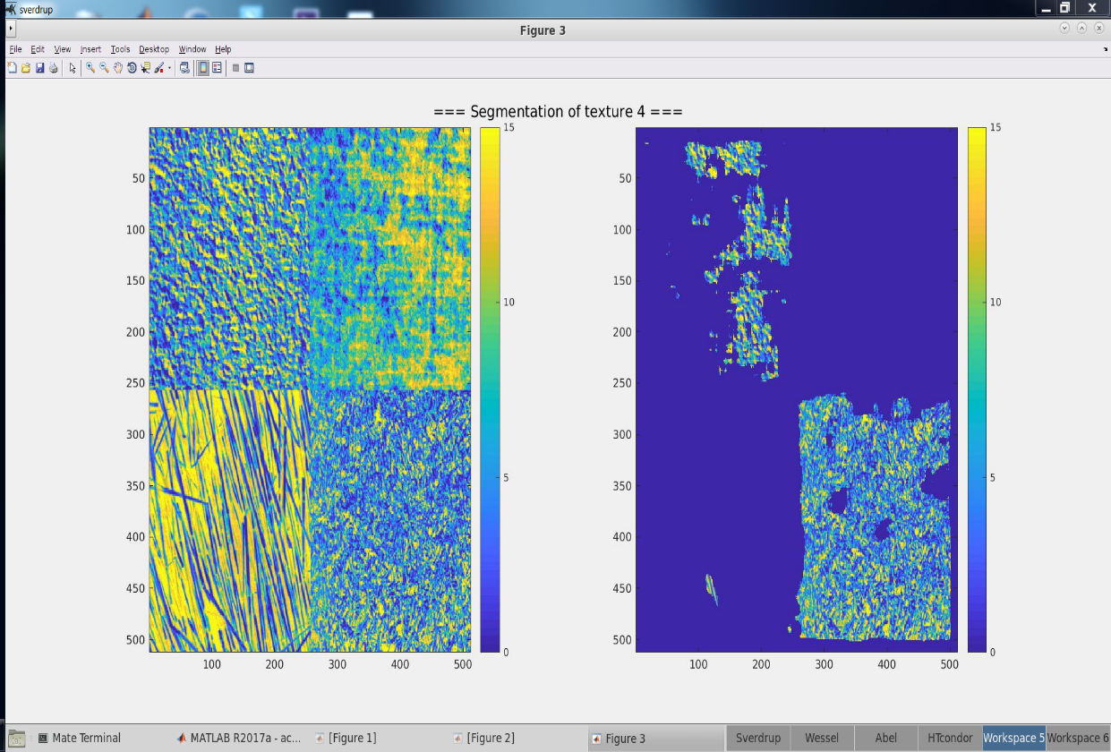

Figure 29. Mosaic-1 and threshold applied image to identify texture-4

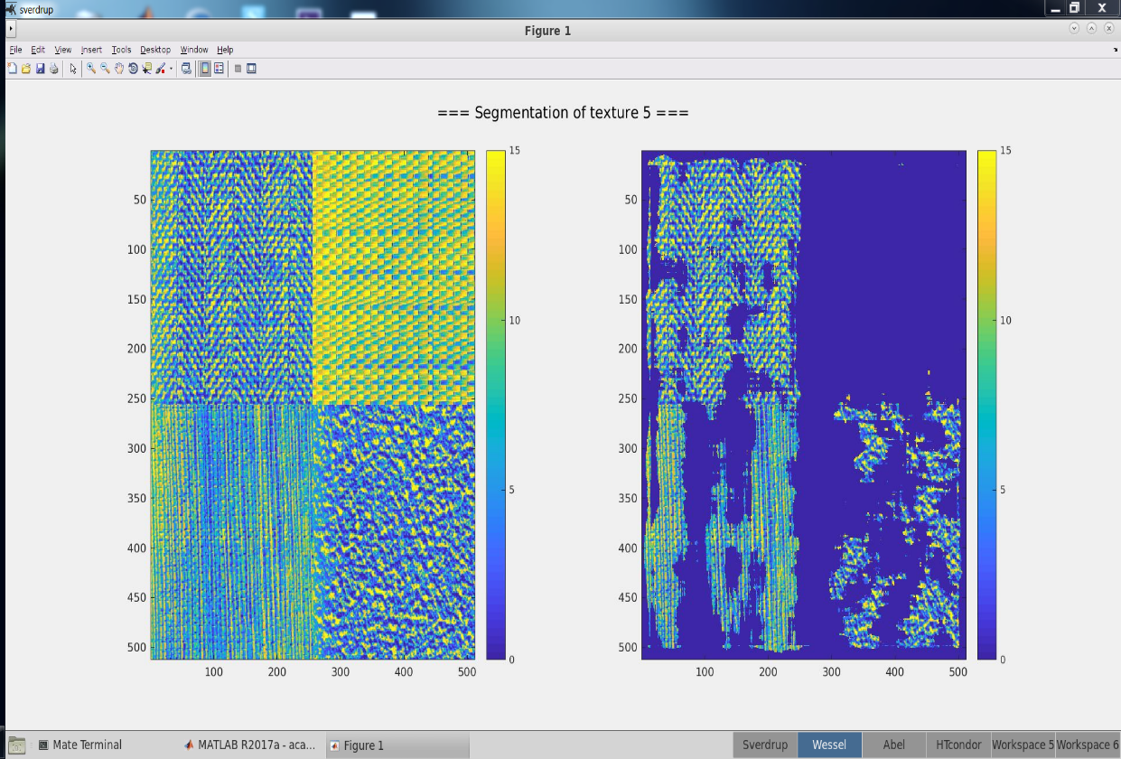

Figure 30. Mosaic-1 and threshold applied image to identify texture-5

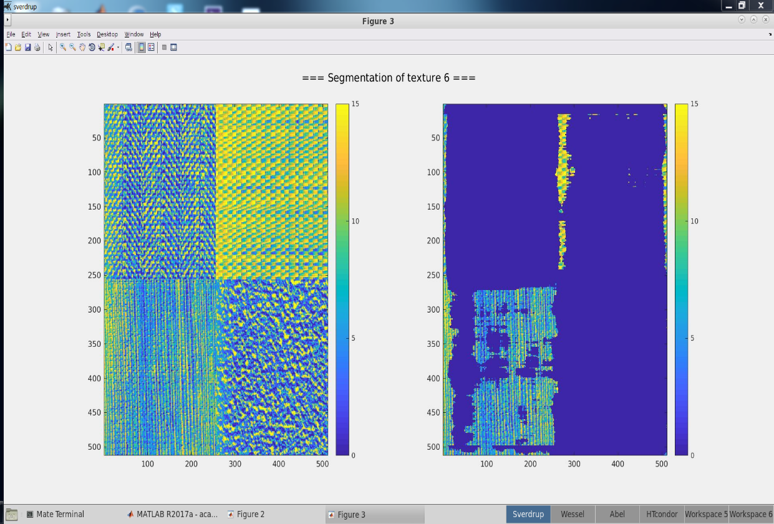

Figure 31. Mosaic-1 and threshold applied image to identify texture-6

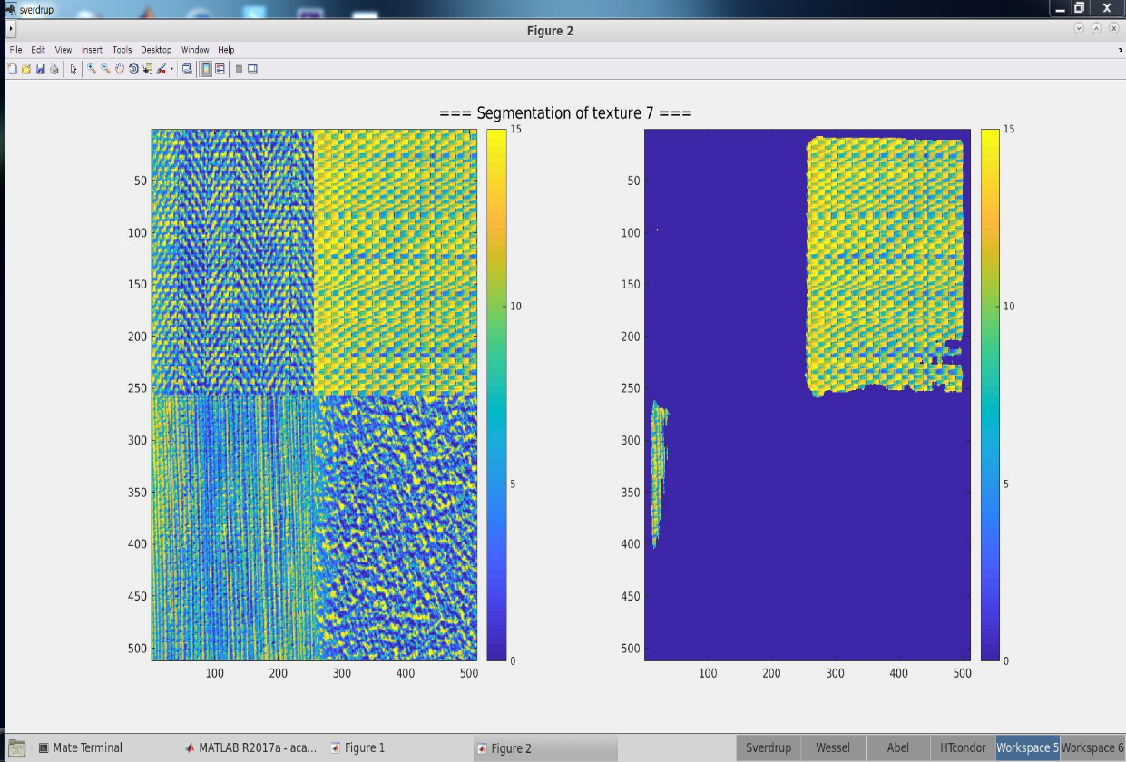

Figure 32. Mosaic-1 and threshold applied image to identify texture-7

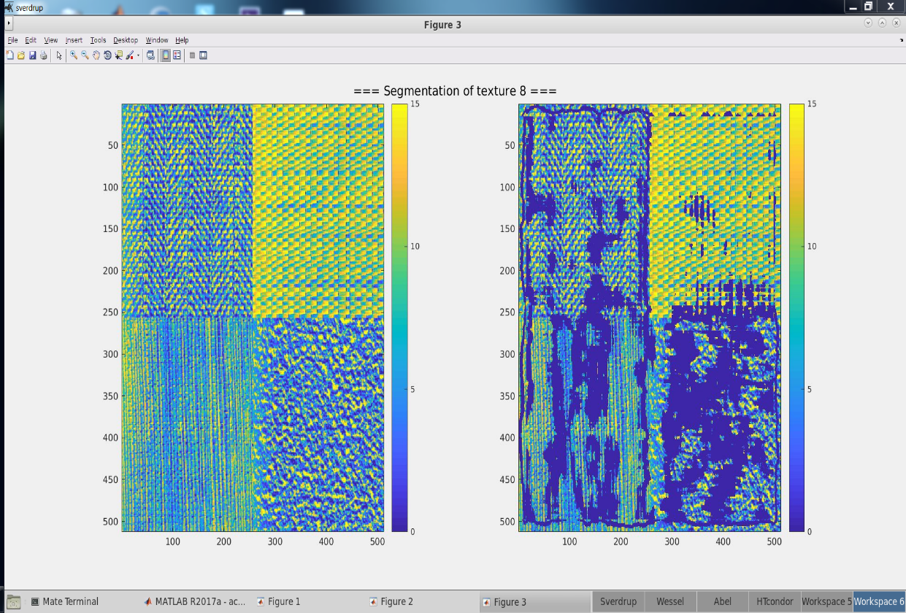

Figure 33. Mosaic-1 and threshold applied image to identify texture-8